**KNN Task**

import pandas as pd

import matplotlib.pyplot as plt

import math

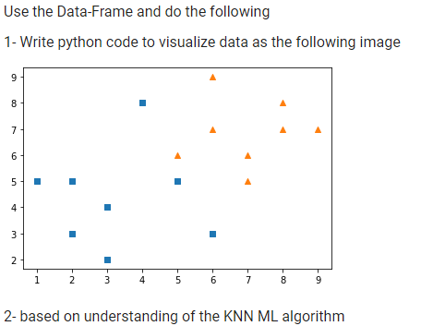

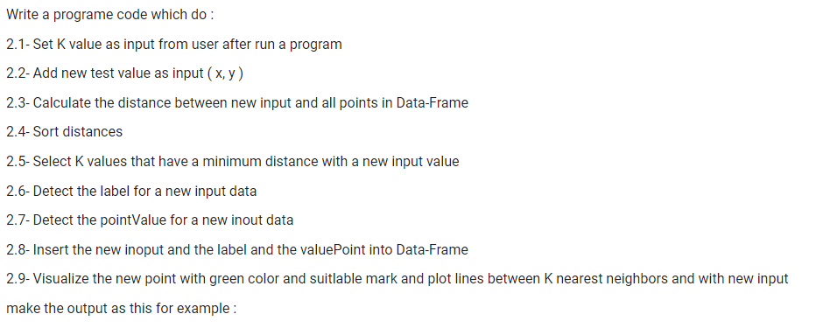

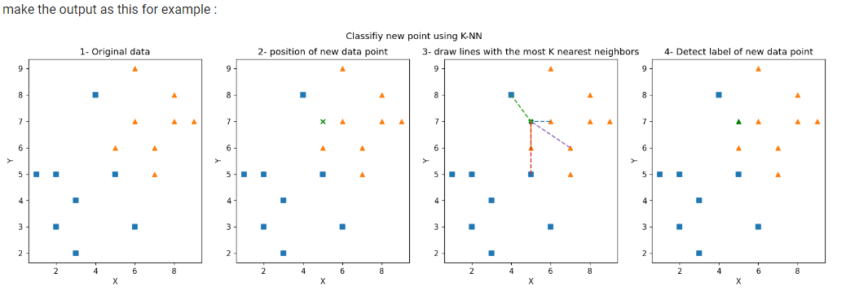

list_data = [[2,5, "square", 50],

             [2,3, "square", 56],

             [3,2, "square", 36],

             [3,4, "square", 80],

             [6,3, "square", 70],

             [1,5, "square", 85],

             [4,8, "square", 60],

             [5,5, "square", 83],

             [7,6, "triangle", 77],

             [6,7, "triangle", 20],

             [7,5, "triangle", 36],

             [5,6, "triangle", 56],

             [9,7, "triangle", 40],

             [8,8, "triangle", 37],

             [8,7, "triangle", 55],

             [6,9, "triangle", 41],

             ]

df = pd.DataFrame(data = list_data, columns=["x", "y", "label", "pointValue"])